Jets_Reporting Instructions

# Data In

## Person

1. Person table must be manually maintained. It is used to link JIRA data to Deltek data.
2. Maintain person.xls file in folder _data/person/person.xls
3. To update person table run “Deltek_to_Person.ktr”.

Note: Person must be updated/maintained to produce accurate and consistent reports.

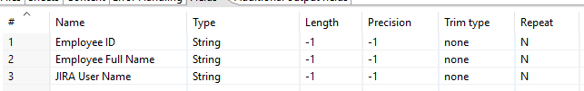

## Jira

1. Export JIRA data as excel .xls file. Naming convention – “JIRA_All_Project_YYYYMMDD”
2. Place file in folder _data/jira
3. Add file to “Excel Input JIRA_All_Project_YYYYMMDD” step in the “ JIRA_to_Work_Log_Hours.ktr”
   1. Add file
   2. Set Sheet name
   3. Confirm Fields
4. Execute “ JIRA_to_Work_Log_Hours.ktr”
   1. This will populate the jets_reporting. jira_logged_work table

Data format for the JIRA xls data must follow the below format. Please remove any additional columns and total rows at the end the file

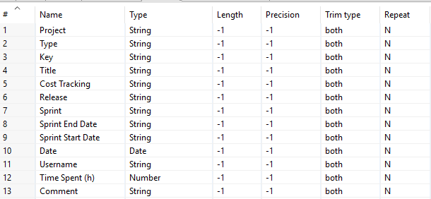

## Deltek

1. Export Deltek data as excel .xls file. Naming convention – “jets_deltek_YYYYMMDD”
2. Place file in folder _data/deltek
3. Add file to “Microsoft Excel Input jets_deltek_YYYYMMDD.xls” step in the “Deltek_to_Enter_Labor_Hours.ktr”
   1. Add file
   2. Set Sheet name
   3. Confirm Fields
4. Execute “Deltek_to_Enter_Labor_Hours.ktr”.
   1. This will populate the jets_reporting. deltek_labor_hours table

Data format for the Deltek.xls data must follow the below format. Please remove any additional columns and total rows at the end the file

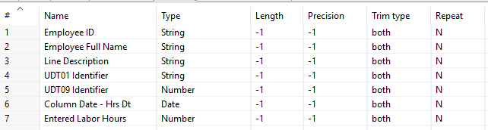

## Views

The reports require the following VIES to be created

### DELTEK_hours_sum_date

Drop view DELTEK_hours_sum_date;

Create view DELTEK_hours_sum_date AS

Select p.employee_id, upper(p.employee_full_name) as employee_full_name, to_char(d.date_hrs_deltek, 'YYYY-MM-DD') as DELTEK_DATE, sum(d.entered_labor_hours) as DELTEK_HOURS from deltek_labor_hours d, person p

where

d.employee_full_name = p.employee_full_name

group by p.employee_id, p.employee_full_name, to_char(d.date_hrs_deltek, 'YYYY-MM-DD')

order by upper(p.employee_full_name),to_char(d.date_hrs_deltek, 'YYYY-MM-DD')

### JIRA_hours_sum_date

Drop view JIRA_hours_sum_date;

Create view JIRA_hours_sum_date AS

Select p.employee_id, upper(p.employee_full_name) as employee_full_name, to_char(j.date, 'YYYY-MM-DD') as JIRA_DATE ,sum(j.time_spent_hour) as JIRA_HOURS from jira_logged_work j, person p

where

j.username = p.jira_user_name

group by p.employee_id, p.employee_full_name, to_char(j.date, 'YYYY-MM-DD')

order by upper(p.employee_full_name),to_char(j.date, 'YYYY-MM-DD')

## Reports

### Missing Data Report

Select name as employee_full_name, date, sum(d_hours) as deltek_hours, sum(j_hours) as jira_hours

FROM (

Select DELTEK_Hours.employee_full_name as name,DELTEK_Hours.deltek_date as Date, DELTEK_Hours.deltek_hours AS D_HOURS, 0 as J_HOURS from DELTEK_Hours_sum_date DELTEK_HOURS

Union

Select JIRA_HOURS.employee_full_name as name,JIRA_Hours.jira_date as Date, 0 AS D_HOURS, JIRA_Hours.jira_hours as J_HOURS from JIRA_Hours_sum_date JIRA_HOURS

order by name,Date

) as missing_data

group by name, date

order by name, date

# File Processing

## Deltek_to_Person.ktr

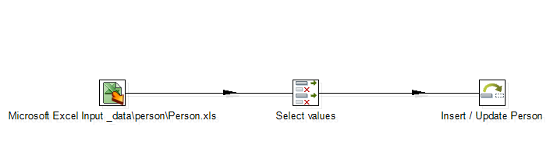

### Insert / Update Person

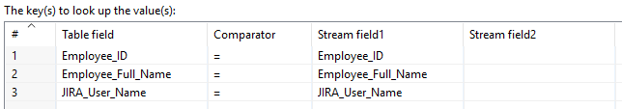

## JIRA_to_Work_Log_Hours.ktr

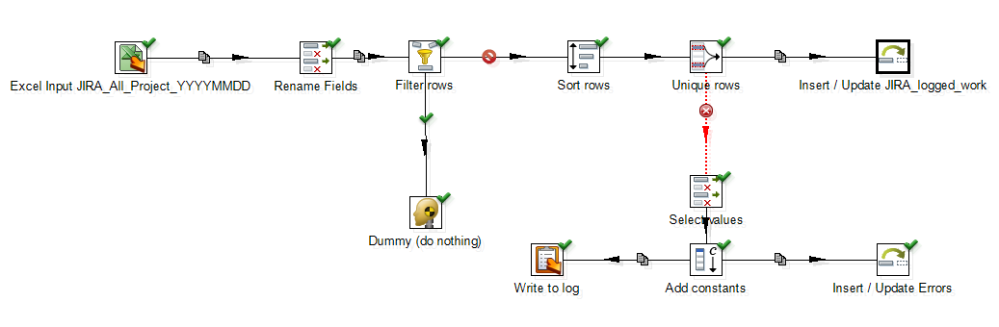

### Insert / Update JIRA_logged_work

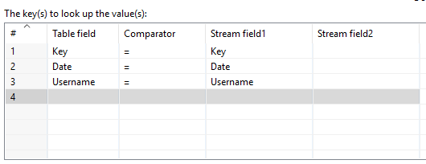

## Deltek_to_Enter_Labor_Hours.ktr

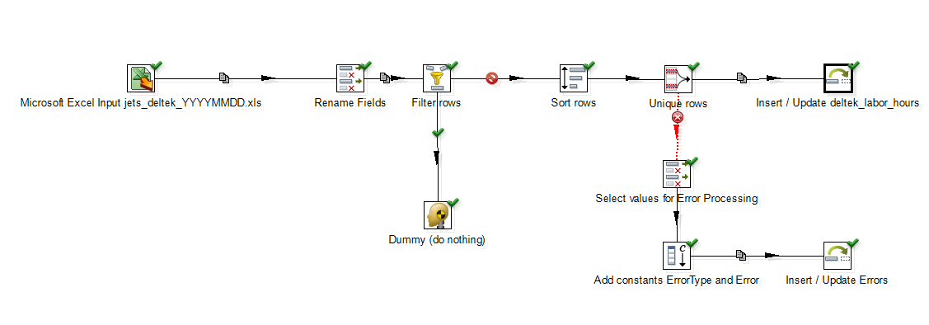

### Insert / Update deltek_labor_hours

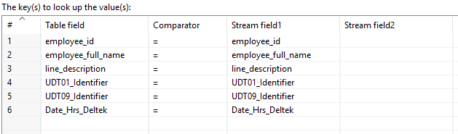

### Report_Missing_Data_Analysis

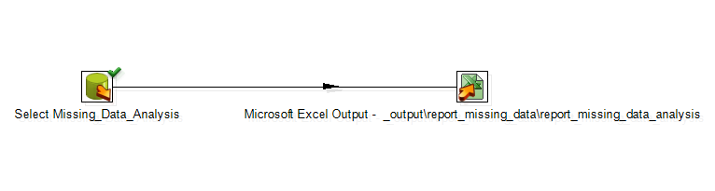

#### Select Missing_Data_Analysis

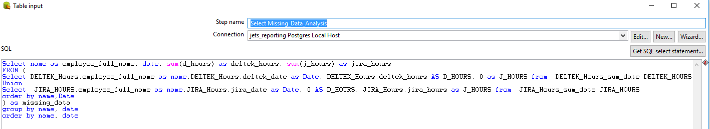

#### Microsoft Excel Output - _output\report_missing_data\report_missing_data_analysis

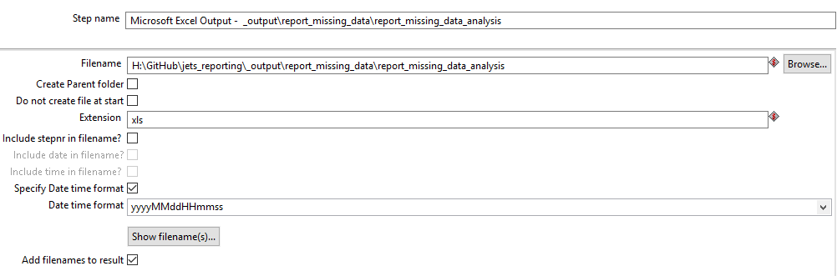

## Test Cases

### Deltek_labor_hours for an Employee for a specific Date

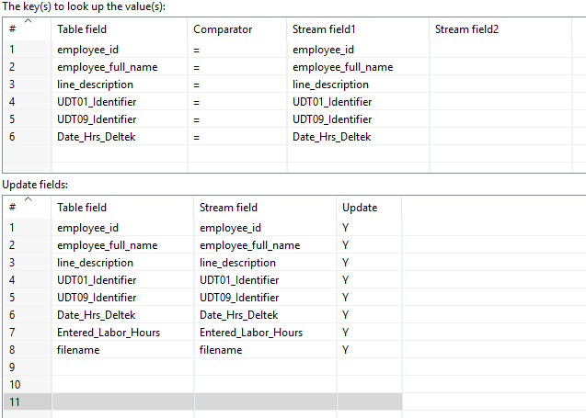

|  |  |  |
| --- | --- | --- |
| Rule | Action |  |
| Any field above that does not match | New record is inserted in to the deltek_labor_hours table |  |
| All fields above match | Record in deltek_labor_hours is updated based on mapping |  |
|  |  |  |
|  |  |  |

### JIRA_logged_work for an Employee for a specific Date

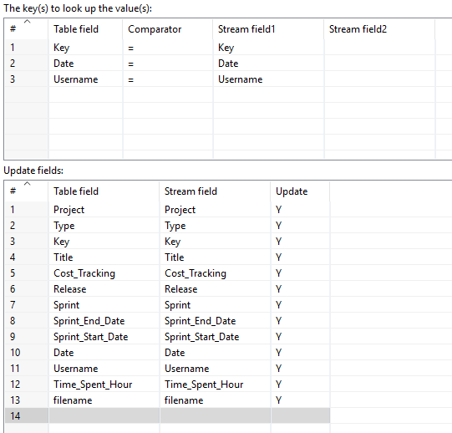

|  |  |  |
| --- | --- | --- |
| Rule | Action |  |
| Any field above that does not match | New record is inserted in to the JIRA_logged_work table |  |
| All fields above match | Record in JIRA_logged_workis updated based on mapping |  |
|  |  |  |
|  |  |  |